Miniature Controller for Heavy Machinery

Mini-Project report submitted in partial fulfilment

of the requirements of the degree of

Bachelor of Engineering

by

Sandeep Mourya EU1152072

Deepak Dabekar EU1152095

Shantanu Nimbalkar EU1152051

Under the guidance of

Ms. Tina D’abreo

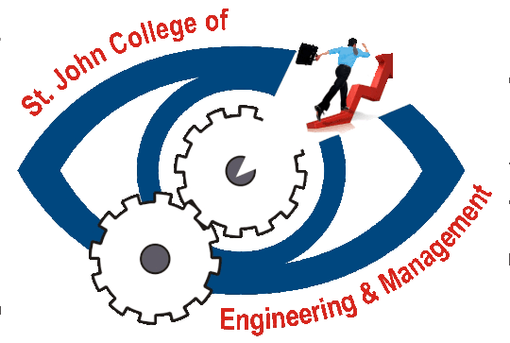

Department of Computer Engineering

St. John College of Engineering and Management

University of Mumbai

2018-2019